User Guide software
JMXConnector

Done by : Djamel-Eddine Boumchedda.

Table of Contents

- Foreword………………………………………………………………….3

  - What does software JMXConnector ?..................................................3

- Step of Start of software JMXConnector………………………………....4

2.1 Get the software JMXConnector under Eclipse………………………4

2.2 Building the Jar of the software JMXConnector……………………4

2.3 Launching the JORAM server, and create the Connection Factory…4

2.4 Launch of the server connector with the application to be monitored..4

2.5 Icon of Software JMXConnector……………………………………..5

3. Test of the server connector, and client connector……………………………5

3.1 Example of registration of objects MBeans to monitor in the
MBeanServer…………………………………………………………5

4. Start the administration tool (JConsole)………………………………………6

4.1 Example of calling the methods (operations) of an MBean…………..9

- Foreword

  - What does software JMXConnector?

JMXConnector allows for the monitoring of a remote application through the JORAM MOM using the JMS API for sending and receiving asynchronous requests.

2. Step of Start of software JMXConnector

2.1 Get the software JMXConnector under Eclipse

The software is open source and is available on the SVN at the following address:
svn : / / svn.forge.objectweb.org / svnroot / joram / ​​trunk / jmx-connector

2.2 Building the Jar of the software JMXConnector

The project is under Maven, so the construction of the jar is made with:
maven install, you can find it by right-click on the project, and then RunAs and
MavenInstall.

2.3 Launching the JORAM server, and create the Connection Factory

To start the JORAM server, simply open a command terminal, and position yourself in the project directory JORAM following:
workspace \ joram \ samples \ src \ joram.

And then enter this command: ant single_server and the JORAM server is launched!

SimpleAdmin class contains a main method in which we created the ConnectionFactory, and which is saved in the JNDI.

2.4 Launch of the server connector with the application to be monitored

The launch of connecteurServeur is done in two phases together in a single step.
First, start a terminal command.
The command to start the connector server agent is:

java -javaagent:" Location of the Jar of the JMXConnetor software
–jar jar of the application that registers MBeans in MBeanServeur.

The location of Jar of JMXConnector is in the target directory of your workspace, in my case the location is :

"c:\Documents and Settings\boumchedda\workspace\JMXConnector\target\joram-jmx-connector-0.1.0-SNAPSHOT.jar"
→ Do not forget to add the claws (" ").

And below, the location of my executable jar, that registers MBeans in MBeanServeur

"c:\Documents and
Settings\boumchedda\Bureau\MBeansToMBeanServer.jar".
→ Do not forget to add the claws (" ").

2.5 Icon of Software JMXConnector

After this command you will see an icon at the bottom right of the taskbar is created (which displays a count of 0 to 100 and then again at 0), by double clicking on it you will see a PopUp, confirming that the connector server is well underway!.
The icon disappears when the connector stops or is interrupted.

3. Test of the server connector, and client connector

In the directory src / test / java are found all the classes necessary to test the connector server and the client connector, launching its own applications to monitor.

the JmsJmxConnectorServerLaunch Class allows start the connectorServer via the main method, which is not the case when the connecteurServeur is launched in agent like in the Part (2.3), we use the method premain

The JmsJmxConnectorClientLaunch Class, allows start the client connector via the main method, and doing tests on the server connector by making several calls JMX.

3.1 Example of registration of objects MBeans to monitor in the MBeanServer

In The class MBeansToMBeanServer exist a method: registerMBeanToMBeanServer which records an MBean in a MBeanServer, this method takes as parameters the object MBean to be registered, and the reference to the MBeanServer, it returns the object name with which the MBean has was recorded.

4. Start the administration tool (JConsole)

Open a command terminal and type : jconsole -J-
Djava.class.path="%JAVA_HOME%\lib\jconsole.jar";"%JAVA_HOME%\lib\tools.jar" ;

The location of the Jar of the JMXConnector software created by doing maven install.

All the jars that make up the application JORAM ;

→ Do not forget to take into account ; where it is put.

-J –D SizePoolRequestor = poolRequestor size used by JConsole, which will contain the
requestor that allow to send requests JMS, and receive responses calls JMX which are
server side.

→If the input size is less than or equal to 0 or is not entered, a default value will be used, and you will see a JDialogue inform you that the size of poolRequestor has not been entered and that a default value was taken.

-J –D jmx.remote.protocol.provider.pkgs=joram.jmx.remote.provider : Here nothing to do, you copy and paste on the terminal, this is the package where the two connectors (Server and Client) are, it is important to give to the JConsole, so she can find the client connector, and so connect to the server connector, and then doing the administration of the MBeans registred in the MBeanServer.

→ In my case the locations of all the jars of the applications that make up the JORAM
application are:

"C:\Documents and Settings\boumchedda\workspace\JMXConnector\target\joram-jmx-connector-0.1.0-SNAPSHOT.jar";"C:\Documents and Settings\boumchedda\workspace\joram\ship\bundle\a3-common.jar";"C:\Documents and Settings\boumchedda\workspace\joram\ship\bundle\a3-osgi.jar";"C:\Documents and Settings\boumchedda\workspace\joram\ship\bundle\a3-rt.jar";"C:\Documents and Settings\boumchedda\workspace\joram\ship\bundle\geronimo-jms_1.1_spec.jar";"C:\Documents and Settings\boumchedda\workspace\joram\ship\bundle\jcup.jar";"C:\Documents and Settings\boumchedda\workspace\joram\ship\bundle\jndi-client.jar";"C:\Documents and Settings\boumchedda\workspace\joram\ship\bundle\jndi-server.jar";"C:\Documents and Settings\boumchedda\workspace\joram\ship\bundle\jndi-shared.jar";"C:\Documents and Settings\boumchedda\workspace\joram\ship\bundle\joram-client-jms.jar";"C:\Documents and Settings\boumchedda\workspace\joram\ship\bundle\joram-mom-core.jar";"C:\Documents and Settings\boumchedda\workspace\joram\ship\bundle\joram-mom-extensions-collector.jar";"C:\Documents and Settings\boumchedda\workspace\joram\ship\bundle\joram-mom-extensions-ftp.jar";"C:\Documents and Settings\boumchedda\workspace\joram\ship\bundle\joram-mom-extensions-jmsbridge.jar";"C:\Documents and Settings\boumchedda\workspace\joram\ship\bundle\joram-mom-extensions-mail.jar";"C:\Documents and Settings\boumchedda\workspace\joram\ship\bundle\joram-mom-extensions-scheduler.jar";"C:\Documents and Settings\boumchedda\workspace\joram\ship\bundle\joram-shared.jar";"C:\Documents and Settings\boumchedda\workspace\joram\ship\bundle\joram-tools-jasp.jar";"C:\Documents and Settings\boumchedda\workspace\joram\ship\bundle\monolog.jar";"C:\Documents and Settings\boumchedda\workspace\joram\ship\bundle\org.apache.felix.shell.jar";"C:\Documents and Settings\boumchedda\workspace\joram\ship\bundle\org.apache.felix.shell.remote.jar";"C:\Documents and Settings\boumchedda\workspace\joram\ship\bundle\org.apache.felix.shell.tui.jar"

After this command you will see the JConsole, Choose Remote Process and enter the URL of

the connector server that you can visualize by clicking twice on the icon creates in taskbar

with the launch of the latter.

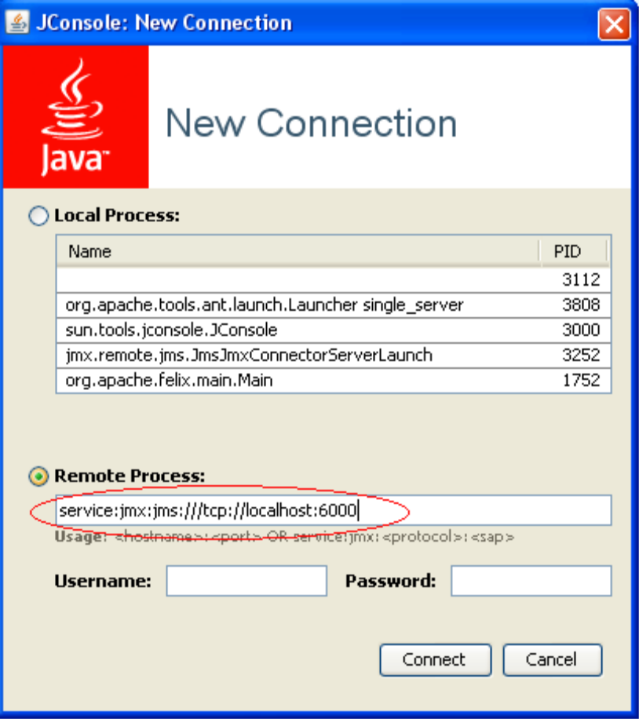

Then click on Connect.

Once you click Connect you will see different tabs (Overview, Memory, MBeans ...)
To view your MBeans registered in the MBeanServer, click on the MBean tab.
Then in the left where there are several directories, choose the directory SimpleAgent, then you will see your MBeans appointed with the object name with which they were recorded in the MBeanServeur, you can then consult their variables, call their methods ...

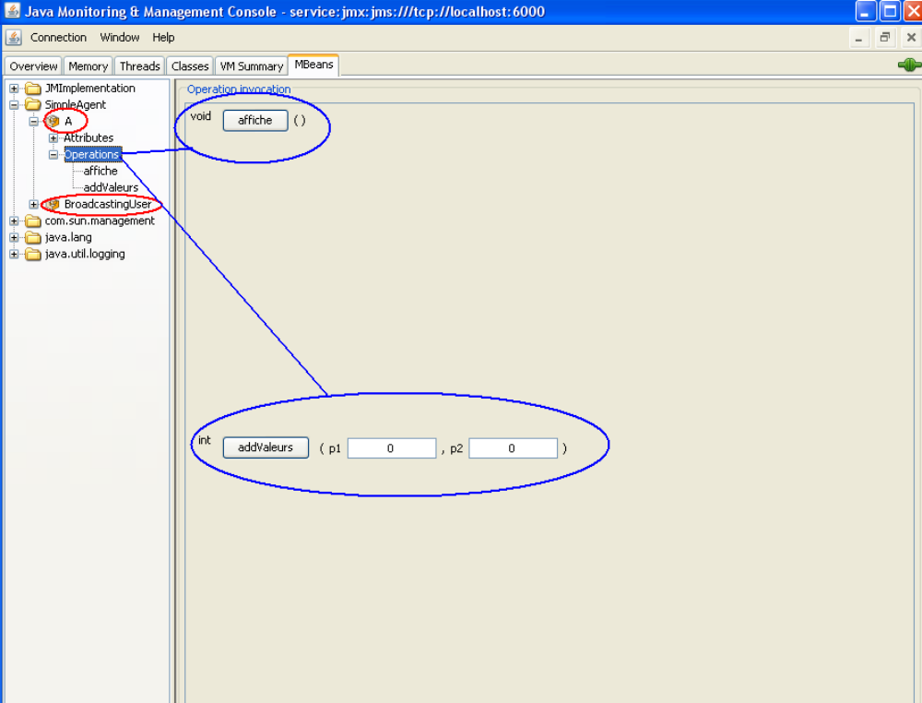

In the MBean tab of the JConsole, you can access the MBean registered in the MBeanServer and call its methods (operations) (see Figure above).

4.1 Example of calling the methods (operations) of an MBean

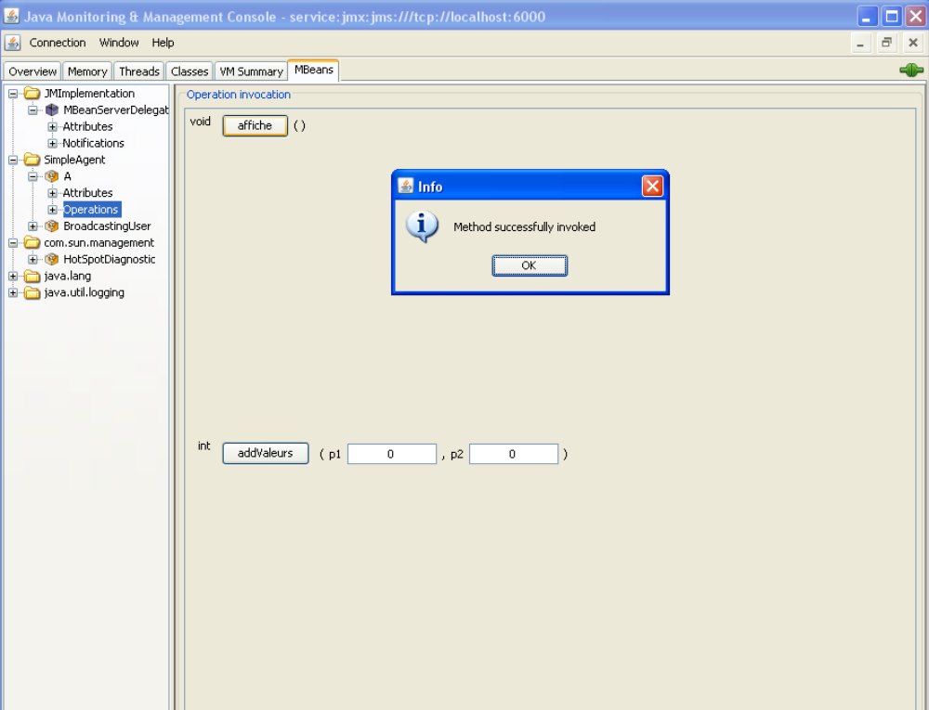

This figure represents the call of the affiche method of MBean A, which displays a string to the JConsole

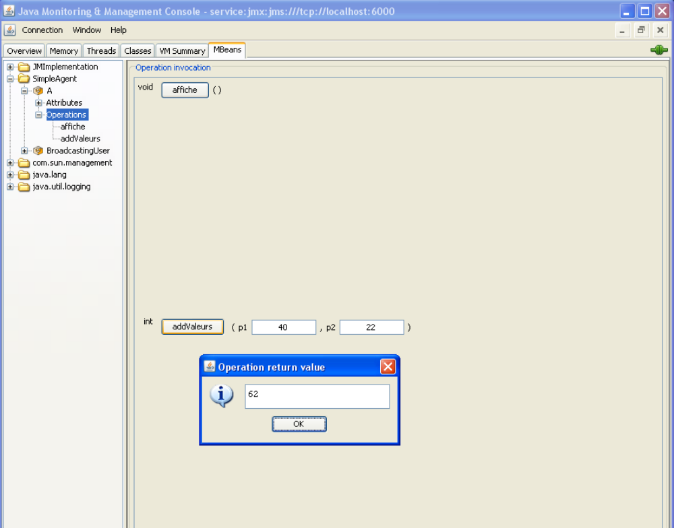

Figure represents the call to method (addValues) of the A MBean, that takes two integer parameters and returns the sum

